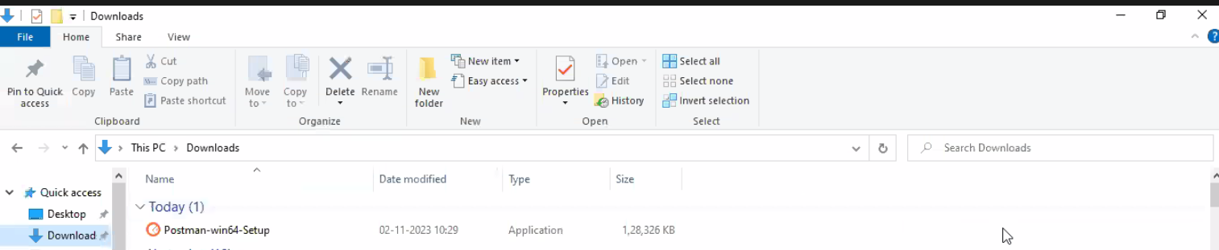

Double click on it to start installation:

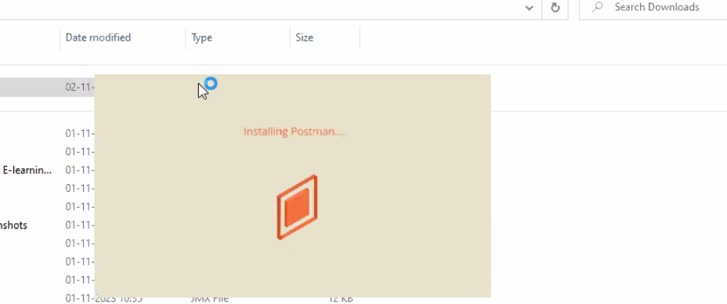

Give a valid gmail id and create postman account:

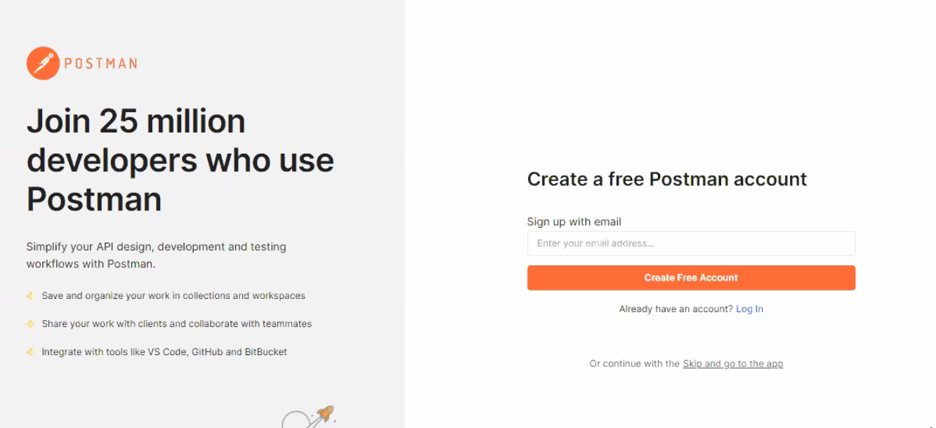

Then it will ask for sign up

After that click on open postman

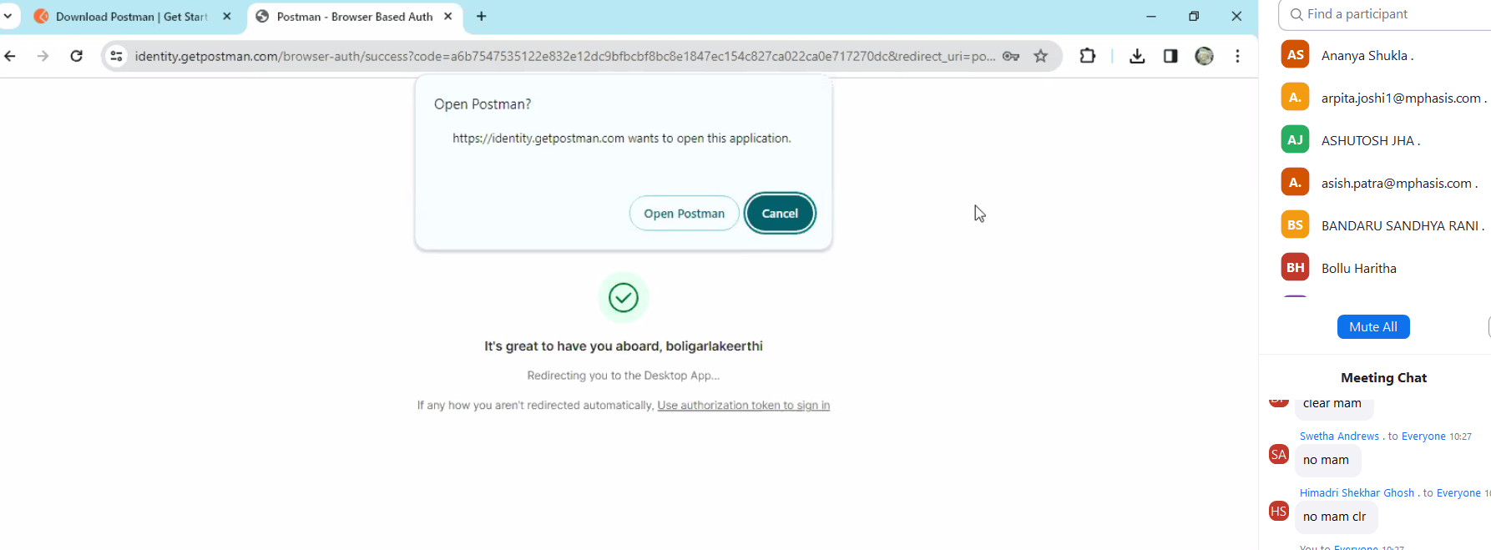

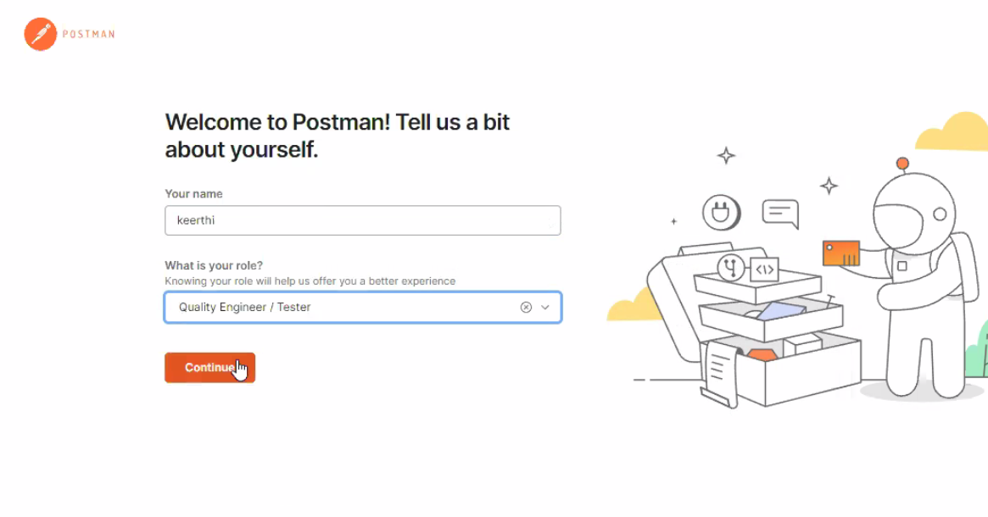

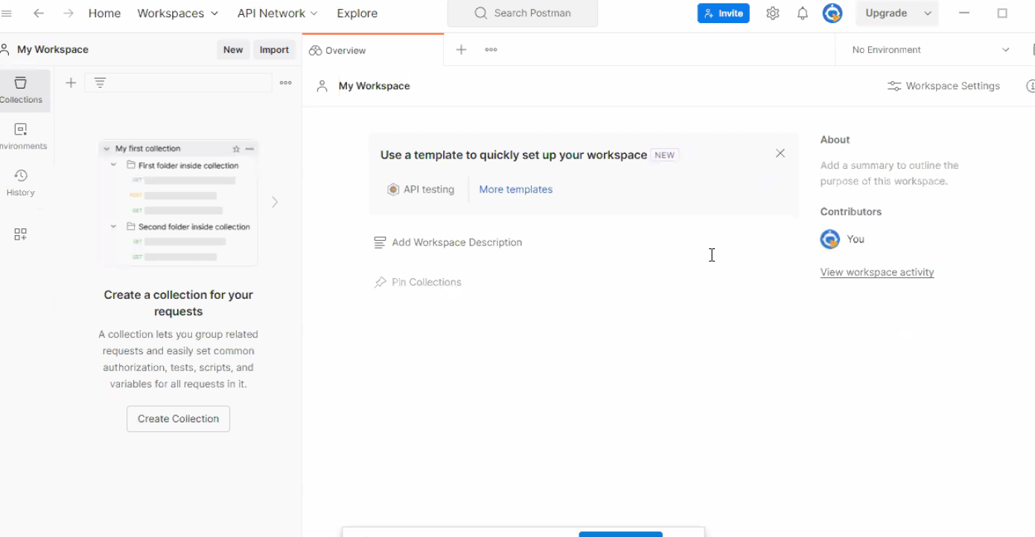

Create a Workspace in postman:

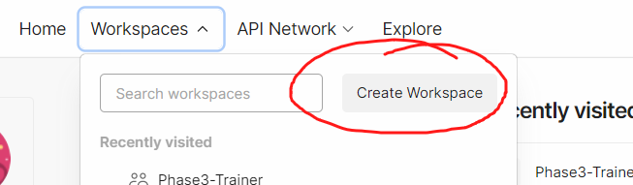

Click on next button

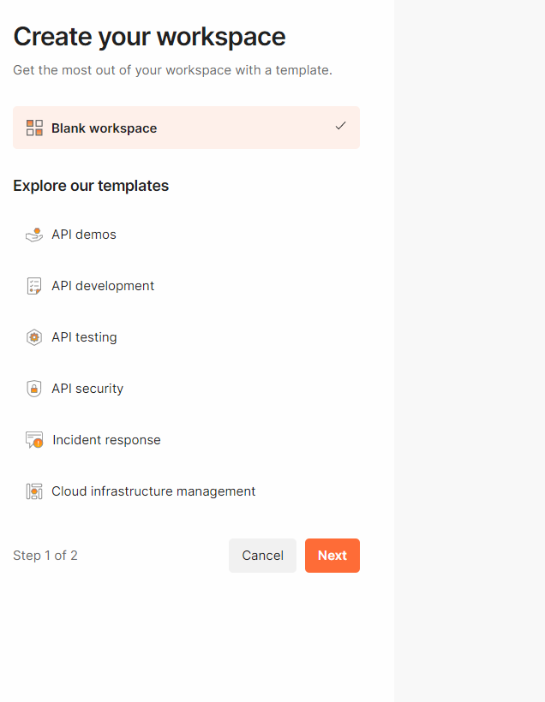

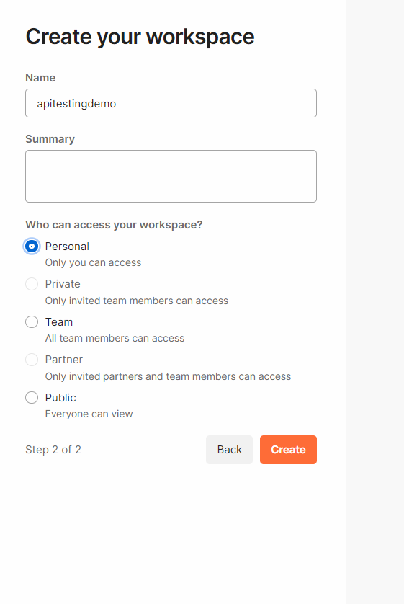

Click on create button and workspace will be created

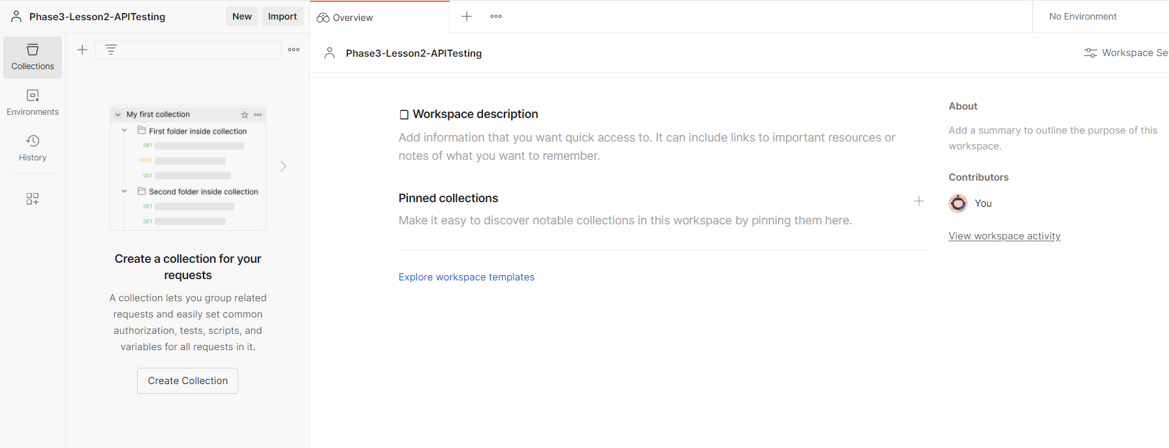

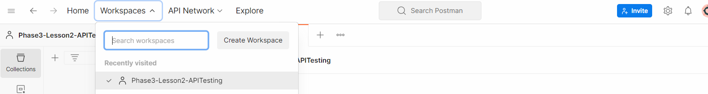

Create a collection first:

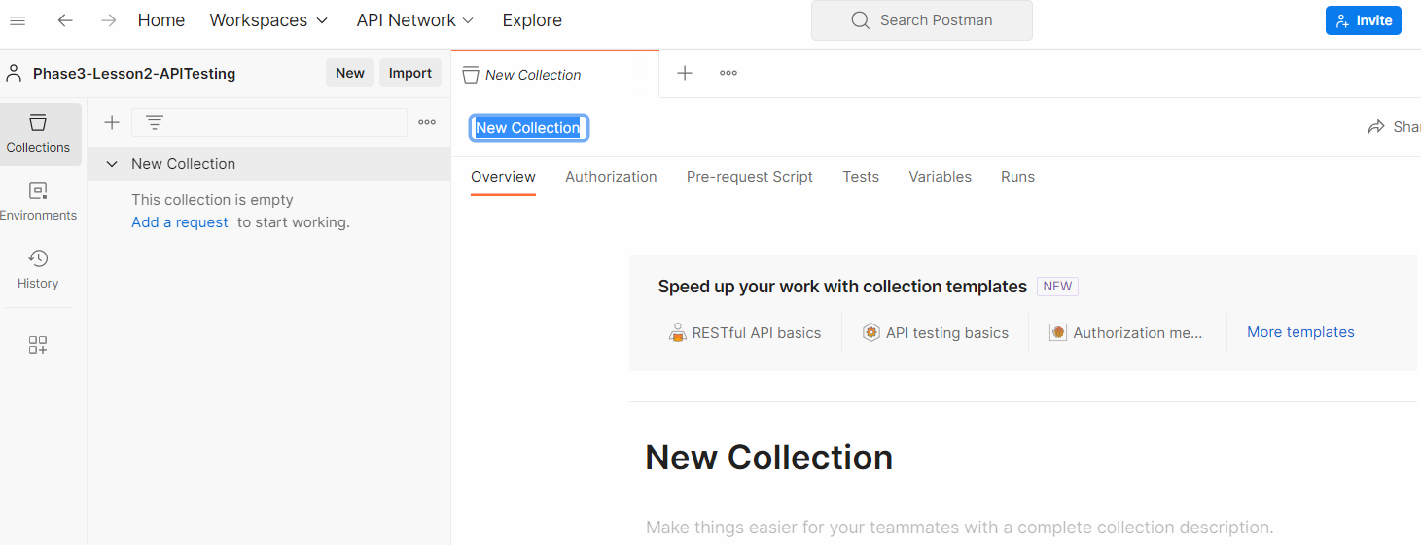

Give a name to the collection on right side:

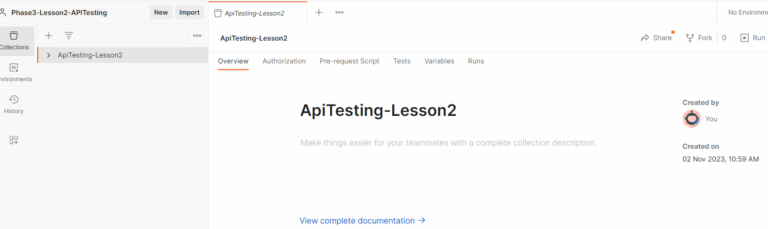

Create a request and understand it:

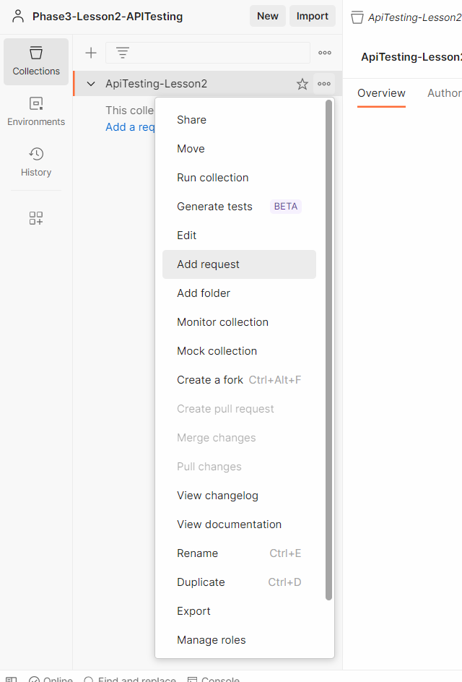

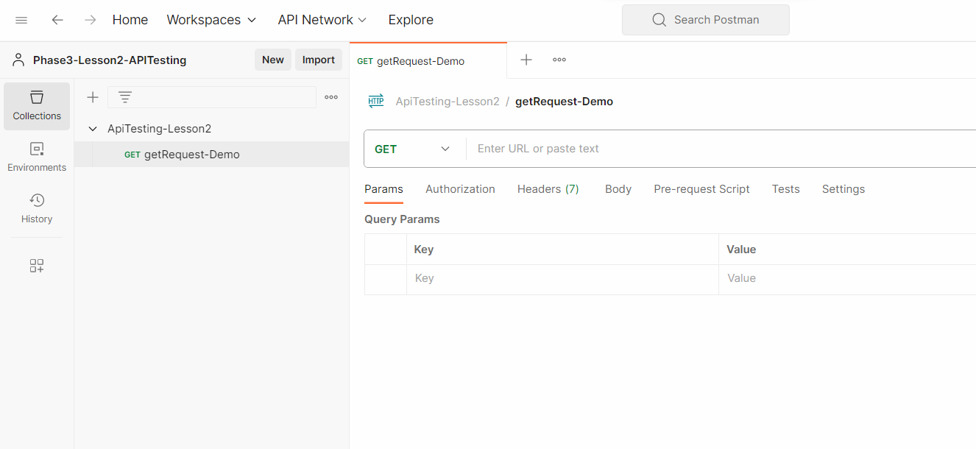

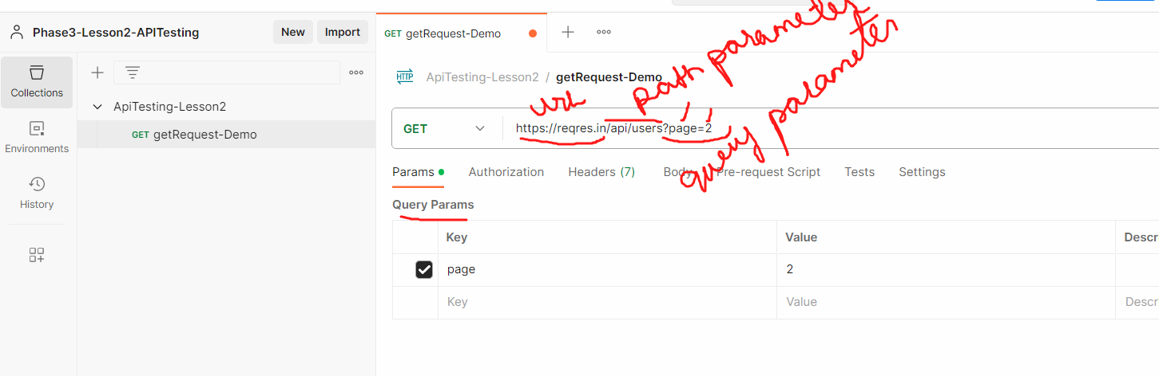

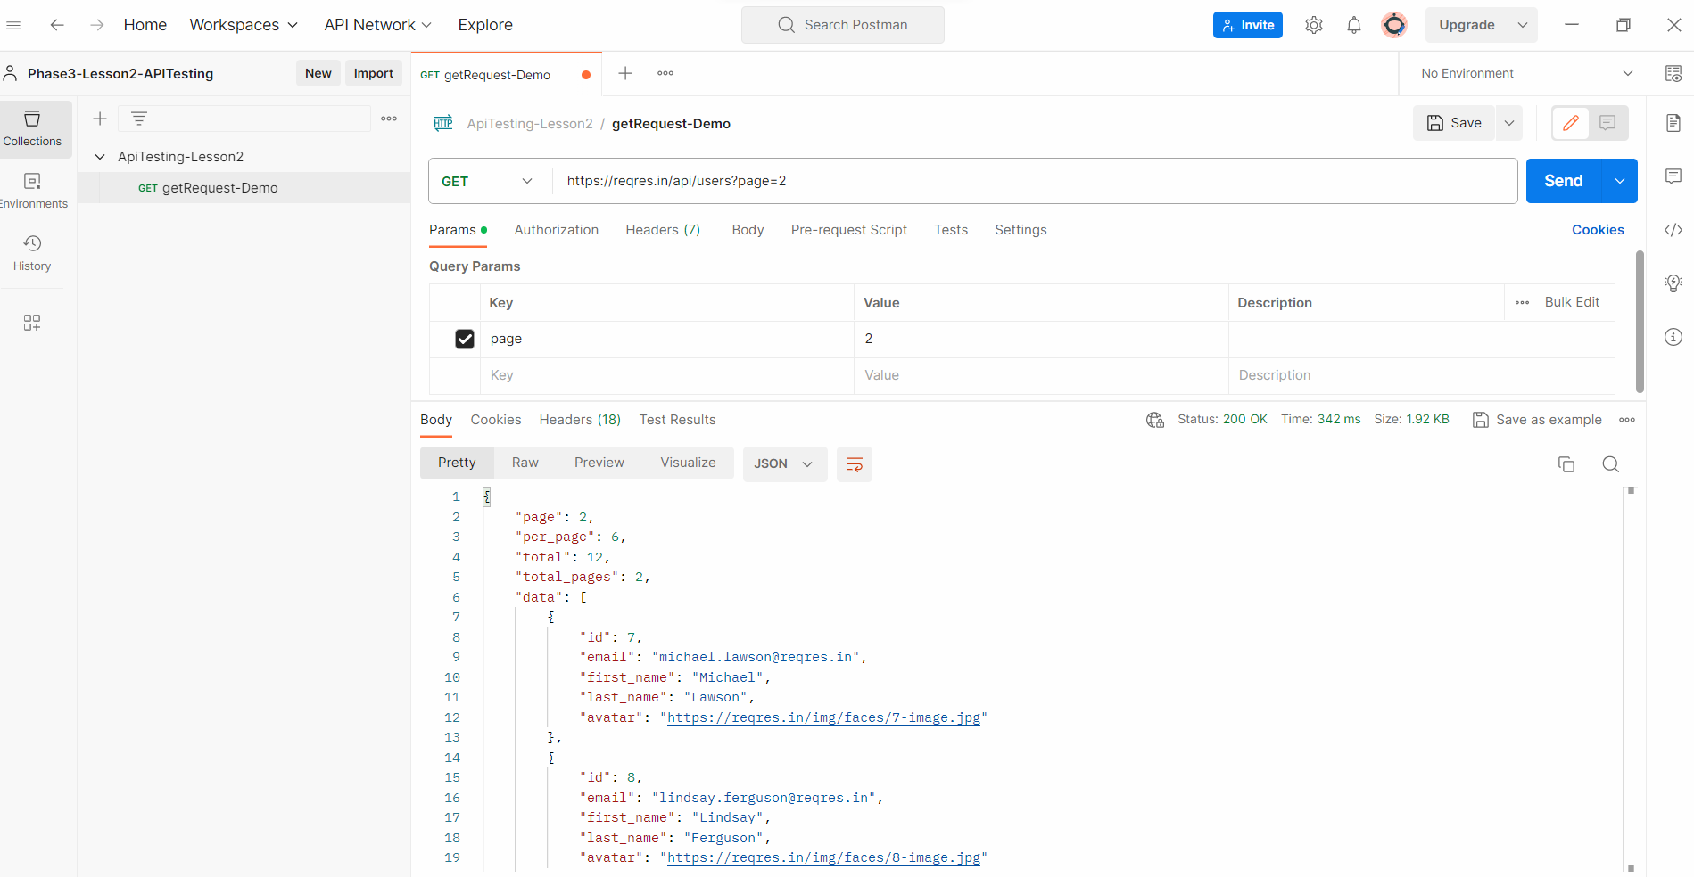

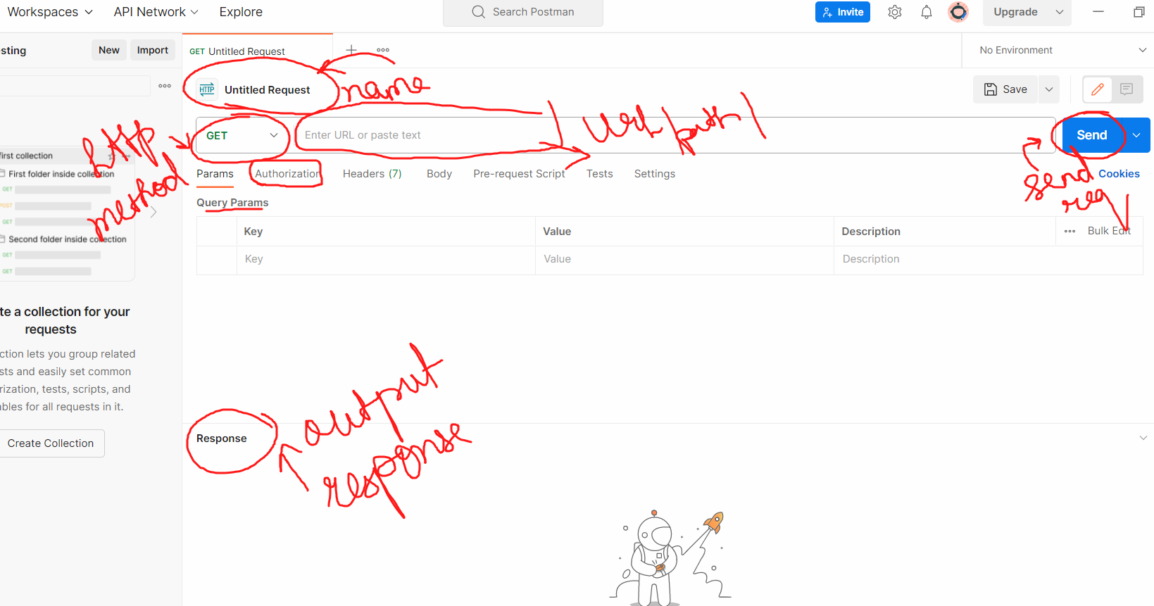

======================Weather Api request- GET method ==========================

<https://openweathermap.org/api>

Signup and loginto this application

Now create api keys -> go to your account🡪 click on my api keys



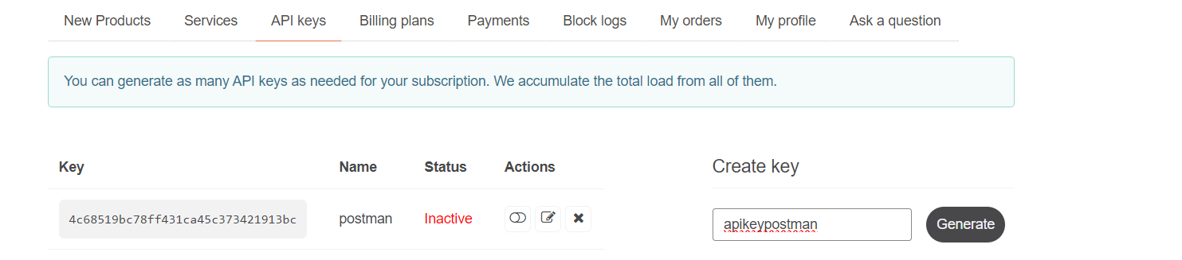

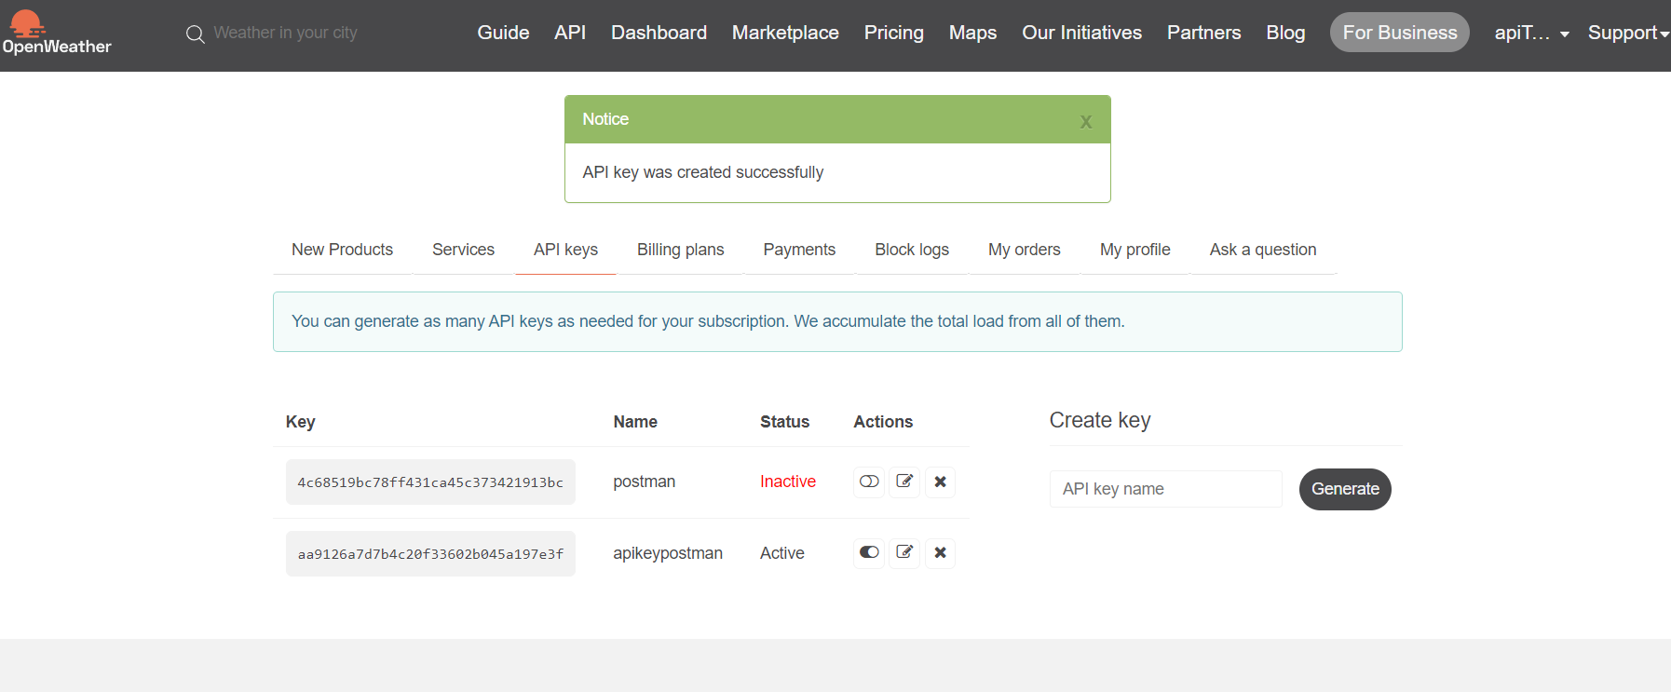

The api request we will sue is :

[https://api.openweathermap.org/data/2.5/weather?q=London&appid={give](https://api.openweathermap.org/data/2.5/weather?q=London&appid=%7bgive) your api key}

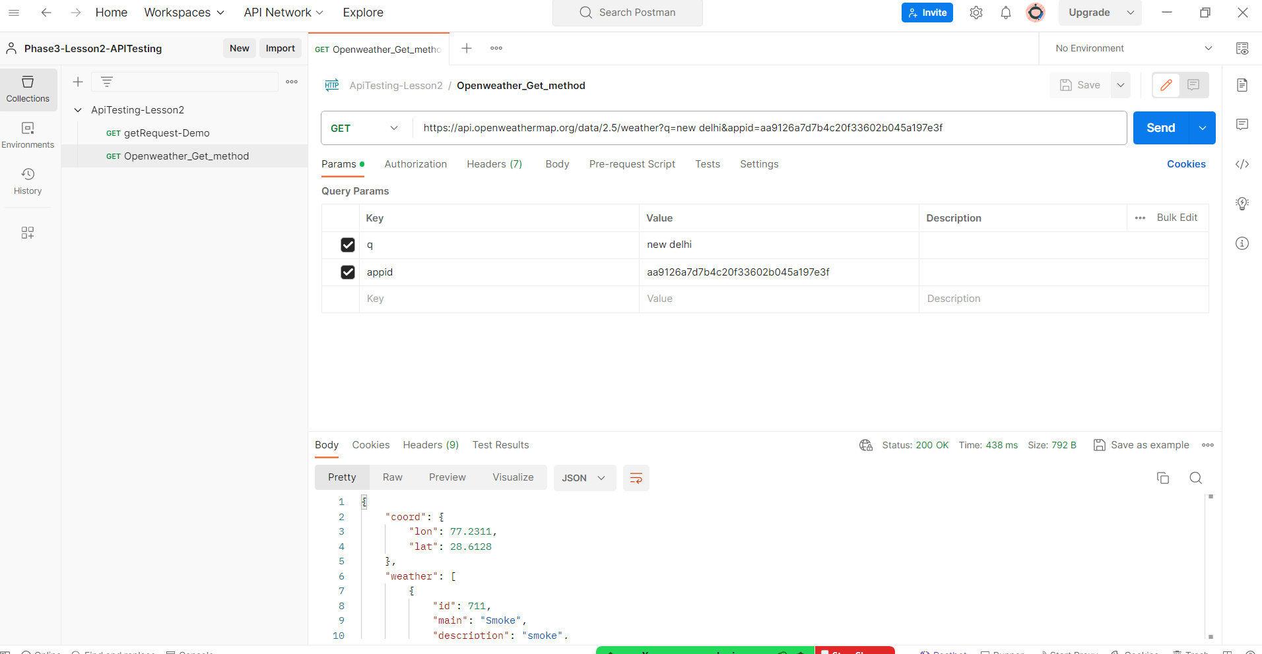

Add and delete parameters

Go to params section of the request

Delete q parameter amd add 2 new parameters lan and lon

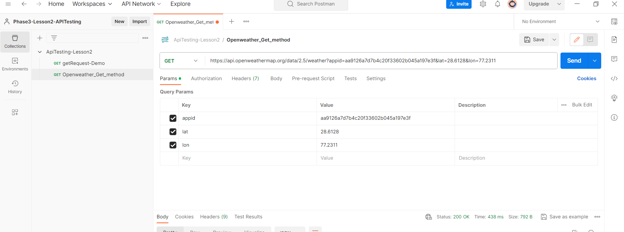

<https://api.openweathermap.org/data/2.5/weather?appid=aa9126a7d7b4c20f33602b045a197e3f&lat=28.6128&lon=77.2311>

Variables & environments in Postman

Create a new request

Repetitive text in the api can be replaced by creating variables.

Variables are created using Environments in Postman

Environment can be considered as we created a Base file in java package

An environment in a workspace is scoped to al of its collection

Lets create an environment :

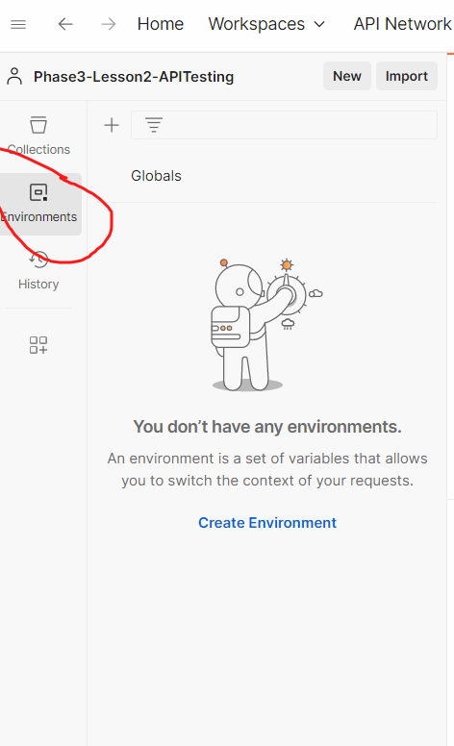

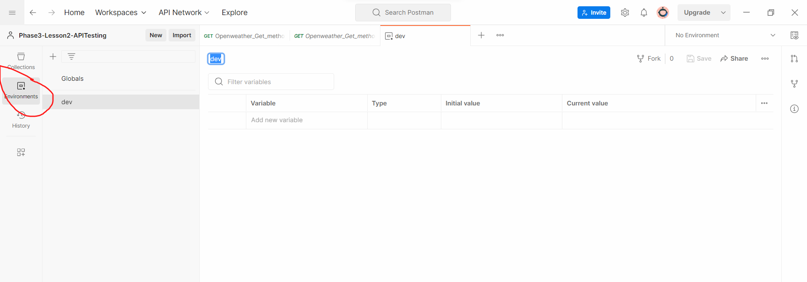

Add variables as shown below and save the environment

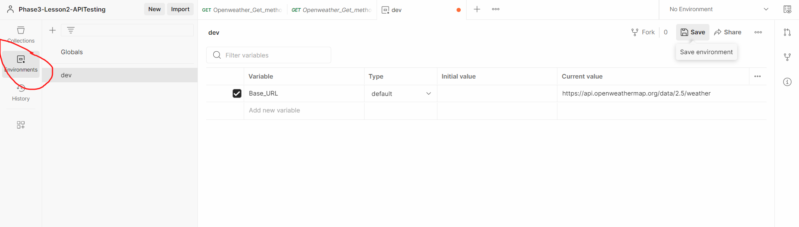

Replace the URL with the variable, but variable is in error as the collection is not attached to the environment

Select the environment

